**Information System Management Lab**

**BCOM 307**

**Assignment #20**

***Submitted by:***

**Name:** YASH JAIN

**Enrollment No:** 03914788818

**Semester:** B.Com(H) 5th Semester

**Class:** B.COM(H)

**Section:** B.Com 5A

**Date of Submission:** 25/10/2021

***Submitted to:***

**Praveen Kumar Singh**

**Assistant Professor, MAIMS**



**Department of Commerce**

**Maharaja Agrasen Institute of Management Studies**

**Affiliated to Guru Gobind Singh Indraprastha University, Delhi**

**Sector -22, Rohini, Delhi -110086, India; www.maims.ac.in**

Maharaja Agrasen Institute of Management Studies

Affiliated to GGS IP University; Recognized u/s 2(f) of UGC Recognized by Bar Council ofIndia; ISO 9001: 2015

Certified Institution Sector 22, Rohini, Delhi -110086, India; [www.maims.ac.in](http://www.maims.ac.in/)

Department of Commerce

Academic Year: 2020-21

Semester: Vth

# Assignment No. 20

# Unit No:

**Course/Subject Code:** BCOM 307 **Subject Title: Information System Management Lab**

# Issue Date Last Date of Submission:

**Instructions for Students:**

# All Questions are Compulsory.

1. The student should attach proper cover page for each assignment clearly mentioning the Assignment No.
2. Each assignment should be prepared by the student individually with proper explaination and screenshots.
3. A4 size ruled sheets should be used for the assignment.
4. Assignment pages should be serially numbered at the bottom of page.

***During online education mode, upload scanned copy of the complete assignment including cover page latest by due date.***

|  |  |  |
| --- | --- | --- |
| **Question No.** | **Question** | **CO No.** |
| 1 | Display the names of the employees who belong to Sales department. | **CO2, CO3, CO4, CO5** |
| 2 | Find out the average salary of Sales department. |
| 3 | Display employee name with designation from marketing department. |
| 4 | Display average salary from each designation. |
| 5 | Display average salary and average commission of IT Department. |

**ASSIGNMENT 20 - SQL SUB-QUERIES**

**Task 1 : Display the names of the employees who belong to Sales department.**

This task can be completed using the **SQL Sub-queries** used with the **SELECT** statement. A Sub-query can be used in the FROM Clause of the SELECT statement. A Sub-query in the FROM Clause defines a data source from that particular SELECT statement. The syntax for this is -

SELECT column1,column2,....columnN from <table> where columnname=(sub-query);

The sub-query would be a query in itself, but used as a part of the WHERE Clause of the SELECT statement. Hence, it coins the term ‘Sub-Query’.

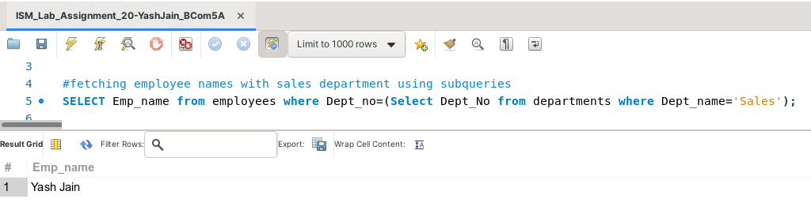

**Task 2: Find out the average salary of Sales department.**

This task can be completed using the **AVG( ) Aggregate function** and **WHERE** clause in the **Sub-Query.**

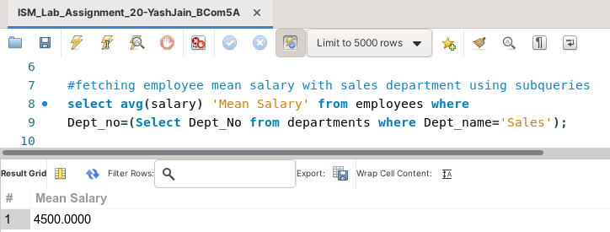

**Task 3: Display employee name with designation from marketing department.**

This task can be completed using the **WHERE** clause in the **Sub-Query.**

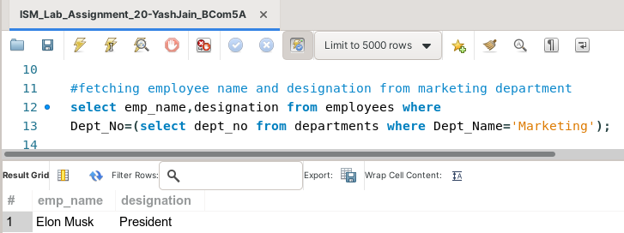

**Task 4: Display average salary from each designation.**

This task can be completed using the **AVG( )** aggregate function, along with the **GROUP BY** clause.

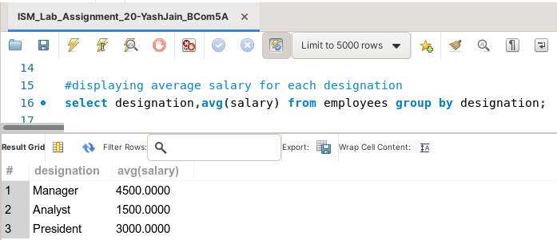

**Task 5: Display average salary and average commission of IT Department.**

This task can be completed using the **AVG( )** aggregate function, and **Sub-Query.**

